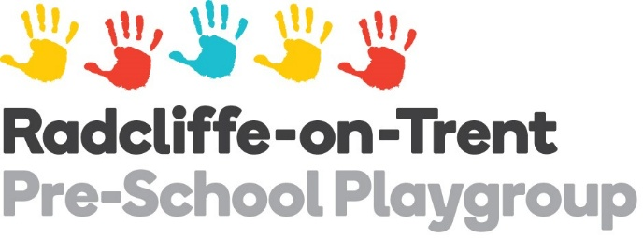
02.1a Fire safety risk assessment form

Risk Area Radcliffe on Trent Pre-School Playgroup 72m sq  Portakabin constructed with steel outer wall, steel roof and galvanised steel floor frame |  | Carried out by Emily Hudson |  | Date 25/9/25
Fire Hazards:  Examples: Ignition; fuel; oxygen | Who is at risk  People on premises and those most vulnerable | Level of risk  of fire occurring and the risk to people | Control measure  Remove and reduce hazards that may cause fire; Remove and reduce risks to people | Review  Record, plan, inform, instruct, train and review
General Fire Risks | 14 staff (typically 2-6 on duty)  Up to 40 children (typically 15-30)  1 child with SEND, with potential to increase in future. PEEP complete. | Low/Medium - Outbreak of fire could result in injury of one or more occupants. | Emergency lighting, fire detection and alarm systems for buildings – tested weekly and tests recorded.  Fire extinguishers in main office. Checked and maintained annually. When seals or pins are missing, these are reported and serviced by a competent fire extinguisher engineer. | Equipment will continue to be checked, as per main policy 2.1.
Electrical equipment and sockets | As above. | Low – Normal fire hazards for this type of occupancy, subject to appropriate controls. | Socket covers in use.  Electrical equipment checked and audited once a year by an approved electrical contractor. This is then certified. | Equipment will continue to be checked annually. Fixed wiring will be tested at least every 5 years. If any damage or faults are found, record in Repairs book, remove them from use or isolate. Have items repaired or replaced by a competent technician. Do not use damaged or faulty items in any part of the building. Do not overload sockets and ensure correct fuse ratings fitted.
Wheelie Bins | As above | Low – Bins kept outside of premises gates. Outbreak of fire unlikely to result in injury of any occupant. | These are emptied weekly by the council so build up of materials is not extreme. They are stored away from the building, the other side of our gate. Indoor waste is moved to these daily. | Where bins are not emptied, report straight to Council on 0115 915 2111, quoting Account No AACC101169. Details can be found on board above Business Manager’s Desk.
Wall Mounted Heaters | As above | Low – Normal fire hazards for this type of occupancy, subject to appropriate controls. | These are checked and serviced annually. | Continue to check annually and report any faults.
Kitchen Area – Cooking Equipment | As above | Medium – Normal fire hazards for this type of area, subject to appropriate controls. Outbreak of fire could result in injury of one or more occupants. | This is kept clean, surfaces clear and storage areas well-maintained. Cleaning regime to maintain this and deep-clean performed once a half term. Extraction and filters regularly cleaned. 2kg CO2 Fire Extinguisher kept in staff office. Wall mounted Fire Blanket available. Heat detector fitted in kitchen. | Ensure a good cleaning routine to keep surfaces and equipment clean from fats and residues.
Quantities of files, documents, stationery, display materials and teaching resources | As above | Medium – Normal fire hazards for this type of occupancy, subject to appropriate controls. | Well-managed storage areas that are checked annually and any outdated records removed. Good housekeeping adhered to and cleaned daily. Electrical distribution installations are clear of combustible materials. | Continue to clear offices and backdated files each Summer to ensure minimal combustible materials on site. Keep digital records, where possible.
Flammable cleaning products | As above | Low – Normal fire hazards for this type of occupancy, subject to appropriate controls. | These are not stored in the same rooms as electrical installations. | Continue to ensure cleaning products are safely stored away from sources of ignition.
Craft equipment | As above | Low – Normal fire hazards for this type of occupancy, subject to appropriate controls. | Water-based paints are used to reduce the risk of flammability and combustion. | Continue to ensure fire-safe products are purchased and safely stored.
Washer/Dryer | As above | Low – Normal fire hazards for this type of occupancy, subject to appropriate controls. | The area around the appliance is regularly cleaned and the lint vent is emptied and cleaned regularly. The dryer is not run while the setting is unoccupied and line drying is used wherever possible. | Continue to ensure appliance is regularly checked and cleaned.

