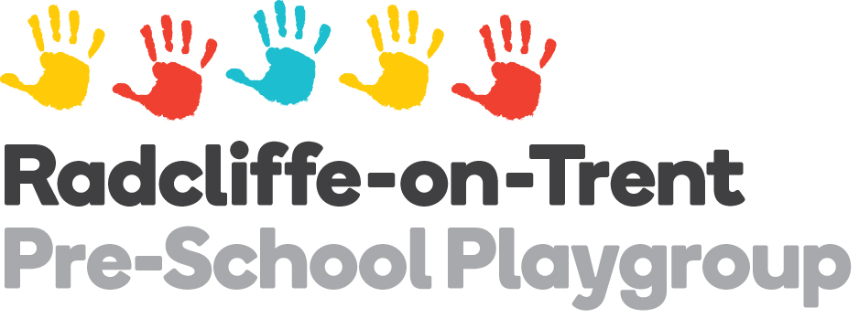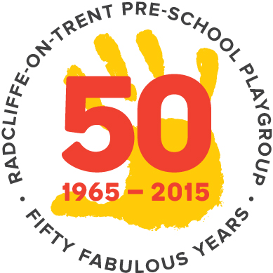

INFORMATION AND APPLICATION FORM

We are an Ofsted registered Pre-school Playgroup, providing high quality care and a play-based learning environment for 2 to 5 year olds. We are open term time, Monday to Friday. We offer the following session options.

Child’s Forename |  | Child’s Surname
Child’s Date of Birth |  | Eligible for funding  (please circle) | YES | NO
Parent’s Name |  | Contact Number
Address |  | Postcode
E-mail Address

Standard Day Session Times and Fees (From September 2024)

Session | Breakfast Club incl breakfast  8 – 9am | Morning incl early start (no breakfast provided) 8.30 – 12noon | Morning  9am – 12noon | Lunch club  12noon -1pm | Afternoon  1 - 4pm | After School Club incl light hot tea  4 – 5pm | Full day  9am-4pm | Extended Full Day  8am - 5pm (incl breakfast and tea)
Price | £8.25 (incl meal cost of £2.00) | £21.87 | £18.75 | £6.25 | £18.75 | £9.25 (incl meal cost of £3.00) | £43.75 | £61.25 (incl meal costs of £5.00)
Monday
Tuesday
Wednesday
Thursday
Friday

I would like my child to start Playgroup from (please give date/term)

Applications to be made online at https://www.rotpreschoolplaygroup.co.uk/apply-online/
Our admissions procedure:
- When your application form is received, we will send you an acknowledgement to confirm that your form has been received, and let you know our availability at that time.
- If your child is over 2 years of age and thus eligible to attend our Playgroup, and we have sessions available, we will contact you to inform you of the choice of sessions available.
If he/she is not yet eligible we will contact you two to six weeks before his/her 2nd birthday, to inform you of the choice of sessions available.
- Lunch club places may only be taken with a morning or afternoon session at Playgroup on the same day.
- If you wish to pursue your application based on the sessions available you will be invited to attend a formal visit to the setting. These visits generally take 2 hours, and allow your child an opportunity to play whilst you stay and fill in the relevant paperwork and meet your child’s key person. Once this visit is completed your child may attend sessions on their own. You will be provided with a Radcliffe on Trent Pre-school Playgroup T-Shirt for your child at your visit.
- If you accept an offer of a place at our Playgroup, we will require a non-refundable £15 Registration Fee (unless your child is in receipt of the Government funding which covers all sessions).
- Where sessions are full we operate a waiting list in line with Nottinghamshire County Council guidelines which state that places must be offered to children in order of age band, with those in the eldest band offered first. The only exceptions to this are for Looked After Children and children eligible for 2 year funding, who will take priority.
- We invoice on a monthly basis on the first of the month for the month ahead, and accept payment online via BACS, or most types of childcare vouchers including Tax-Free Childcare accounts. Payment is expected in full within a month of invoicing.
- Our charge rate (for non-funded hours) is £6.25 per hour and the cost of our standard sessions is shown on page 1. The meal element of Breakfast Club and After School Club is charged separately and is £2.00 for breakfast and £3.00 for tea. The costs of breakfast and tea is NOT covered by Government funding and will be charged for even if your child’s Playgroup sessions are covered by funding.
- We offer the universal 15 hours entitlement to 3 and 4 year olds, and 15 hours to qualifying 2 year olds. We also offer the extended entitlement (up to 30 hours of free childcare from the term after your child has turned 3 (subject to cut-off dates) to eligible working families) upon proof of eligibility, obtained by you through HMRC.
- Please contact our Business Manager at rotplaygroupadmin@googlemail.com for further information or any queries about making your application.

FOR PRE-SCHOOL BUSINESS MANAGER USE ONLY:
Application Received Date:
Acknowledgement Sent:
Visit Date:
Start Date:
Registration Pack Sent:
Registration Fee Applicable:
Funding Eligibility:

